Bank Reconciliation Process
Index
Sr. No. | Particulars | Page No.
1 | Download CSV Template | 2
2 | Prepare the CSV File | 3
3 | Uploading the data | 3
4 | Match Bank Data | 4
5 | Reconcile the Bank Statement | 5

In order to import bank statement using CSV, we need to first import the banking statements using csv in standard NetSuite template appropriately then the statements will be matched and after that reconciliation will be done.
1) In order to first prepare the CSV template you need to download the standard template from NetSuite.
The steps to download the standard template is shown below-
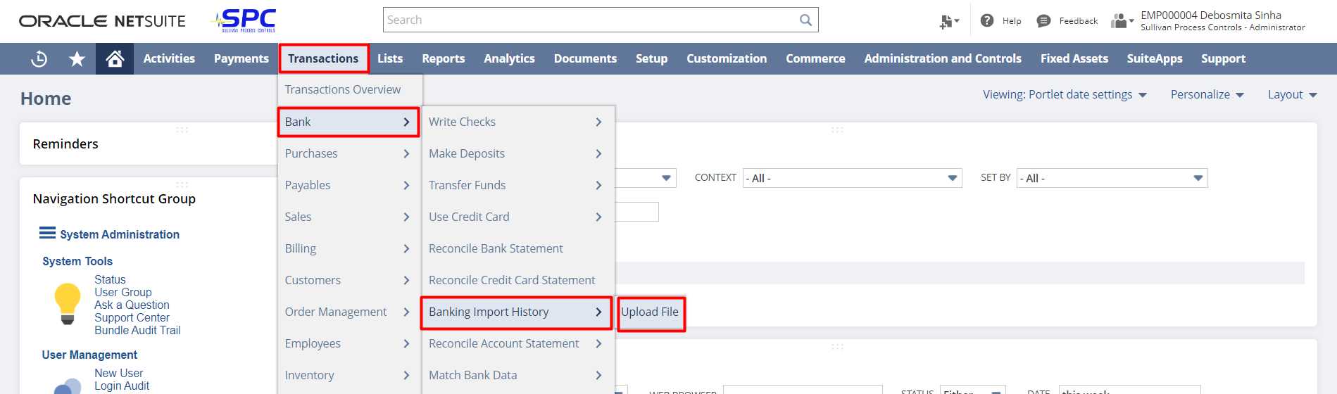
After, clicking on “Upload File” when the next page opens click on “Download the CSV template”. 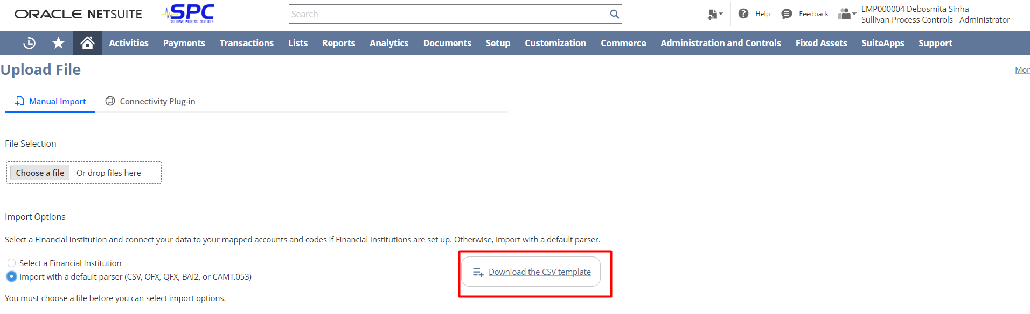
2) Fill up the details of the bank statement that you want to upload.
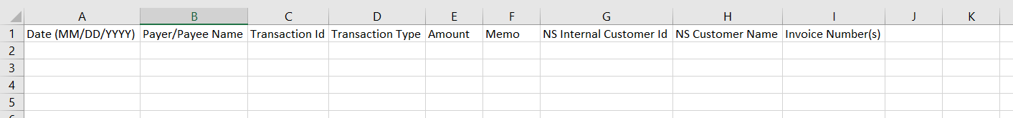
The downloaded template of CSV will look like below-

You need to fill the details properly-
- Date (MM/DD/YYYY) – The transaction date. Content must be in the format of MM/DD/YYYY. If you are using Excel, ensure that the date does not get reformatted.
- Payor/Payee Name– Payor or Payee name.
- Transaction ID – Unique Bank Transaction or Reference ID. This can also be populated with the check number.
- Transaction Type – Values in this column must be one of the following transaction types, all uppercase: CREDIT, DEBIT, CHECK, PAYMENT, ACH, INTEREST, DEPOSIT, TRANSFER, FEE, OTHER.
- Amount – The amount column must be a single column. If your file contains CREDIT and DEBIT columns, combine them into a single amount column. Positive amounts are CREDITS. Negative amounts are DEBITS, and must begin with a minus sign or be in parentheses.
Note-The amount column must not contain currency symbols or commas instead of decimal places. The amount currency should be in the same currency as the selected account.
- NS Internal Customer ID - (This is Optional) The NetSuite internal customer ID. Content must be numeric.
- NS Customer Name - (This is Optional) If the specified customer ID does not match any data, NetSuite uses the value to look up the customer ID. Content is free-form text.
- Invoice Number(s) - (This is Optional) A comma-separated list of invoice numbers in a single field, with no spaces between numbers (for example, 132,133,134). If you use a script or comma-separated file instead of the CSV template in a spreadsheet, put quotation marks around multiple invoice numbers (for example, “132,133,134”). For each invoice number in the list, there is a limit of 128 characters. If the imported file specifies multiple invoices for a transaction, they must all belong to same customer and AR account.

After, filling the necessary details in the CSV template. The sheet will look like this-
3) For, uploading the data we need to follow the below navigation –
“Transactions->Bank->Banking Import History->Upload File”


After, this choose the file you want to upload and select the account and click on “Import”.
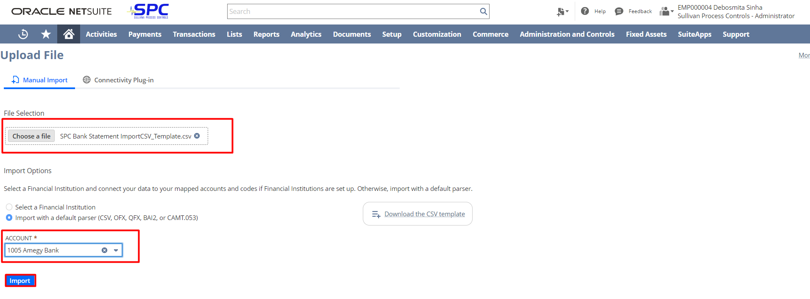
Once the file will be uploaded you can track the status.
To do so, follow the below navigation- “Transactions->Bank->Banking Import History”.
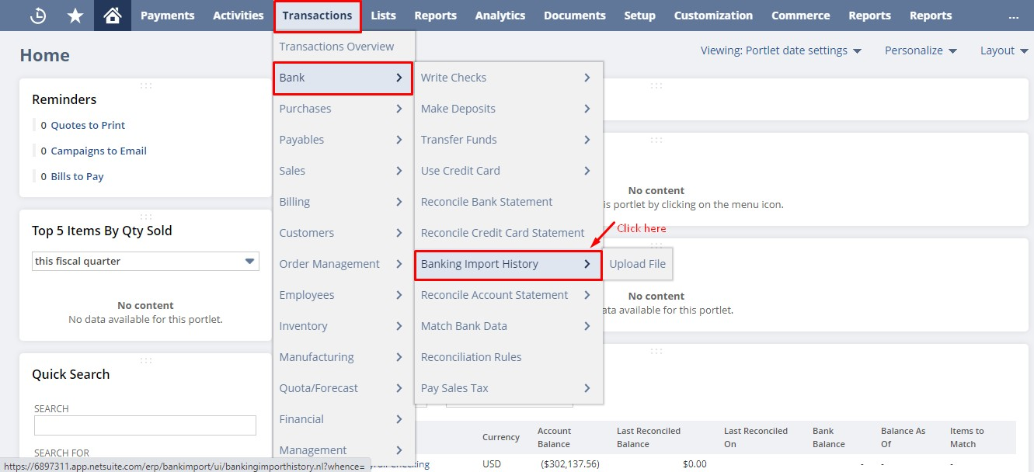
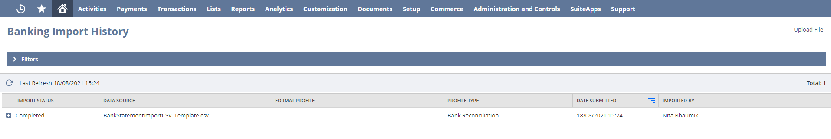
4) After importing the banking history, you need to match the bank data with data already present in NetSuite.
To do so, you need to follow the below navigation- “Transactions->Bank->Match Bank Data”
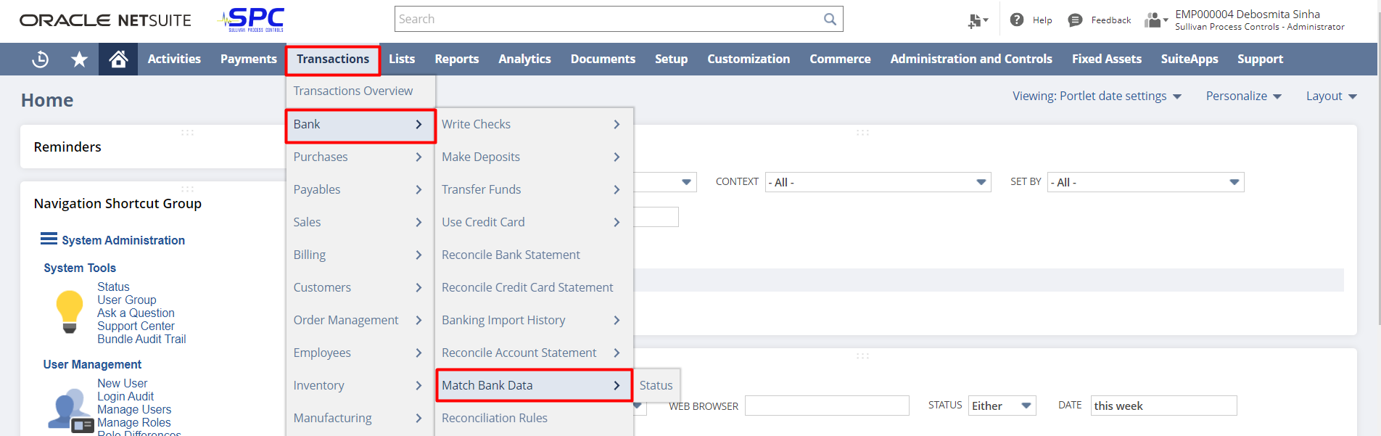
When you enter the page of “Match Bank Data” there you need to follow some necessary steps they are-
- You need to select the account, in which you want to perform the matching.
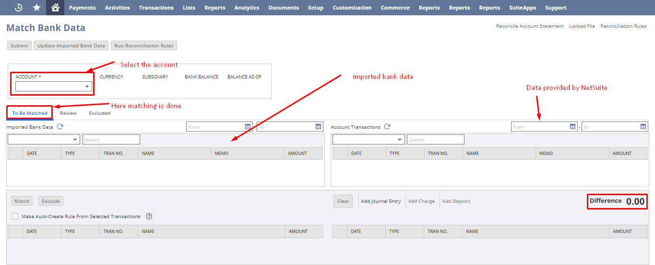
- Then under the “To be Matched” tab you can select the data one by one to match with data that are provided by NetSuite which be in the right side of the screen.

5) After, matching the data you need to reconcile the bank statement.
To do so, you can follow two ways-
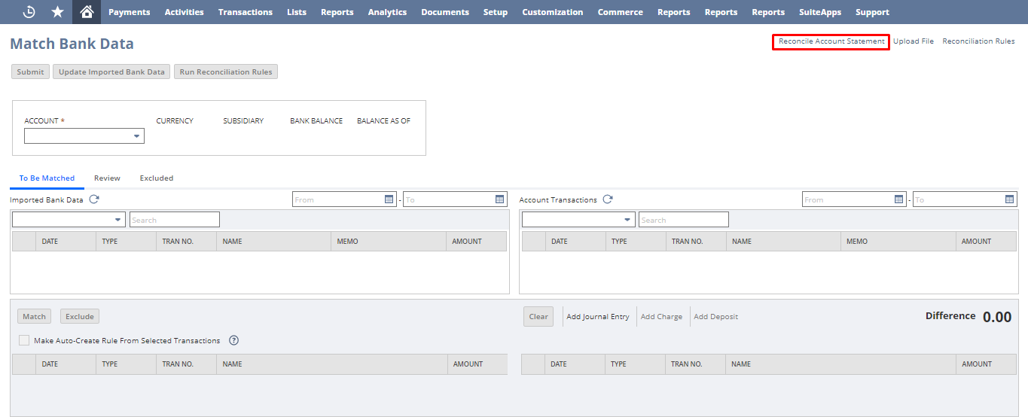
- You can directly click on “Reconcile Account Statement” in the “Match Bank Data” Page.
OR,
- You can follow another navigation-
“Transactions->Bank->Reconcile Account Statement”
Note: The only difference between above two process is that in step 1, you need not to give the account in which you want to perform the reconciliation but in step 2 you have to give the account details.
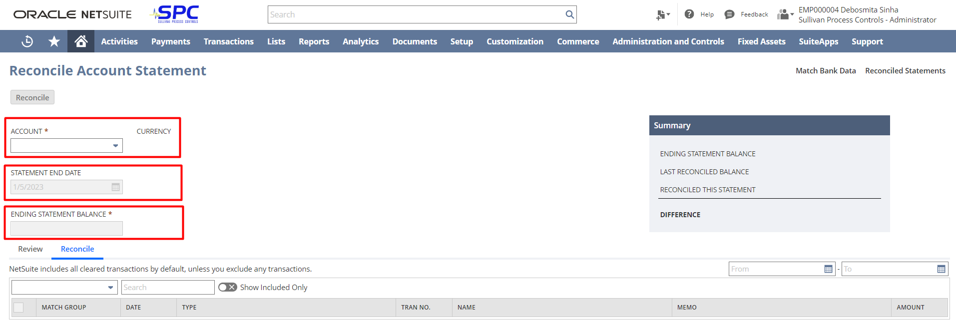Once, you enter the reconcile account statement, you need to enter all necessary information like account, statement end date and ending statement balance, after that click on “Reconcile” button.
Note: A warning will pop-up. Read it carefully and proceed after that.
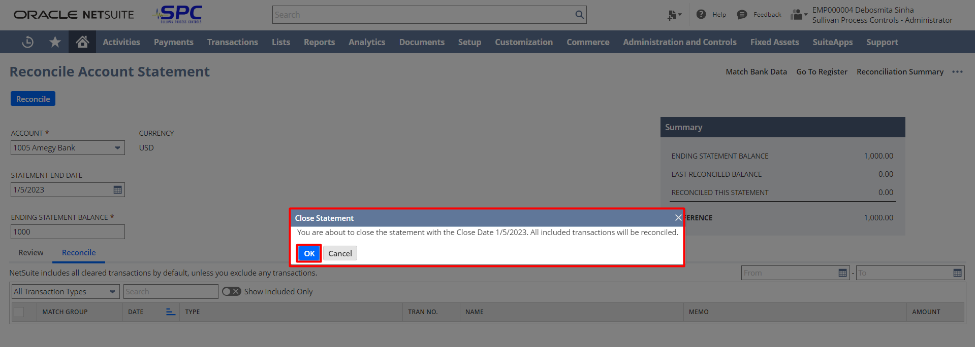



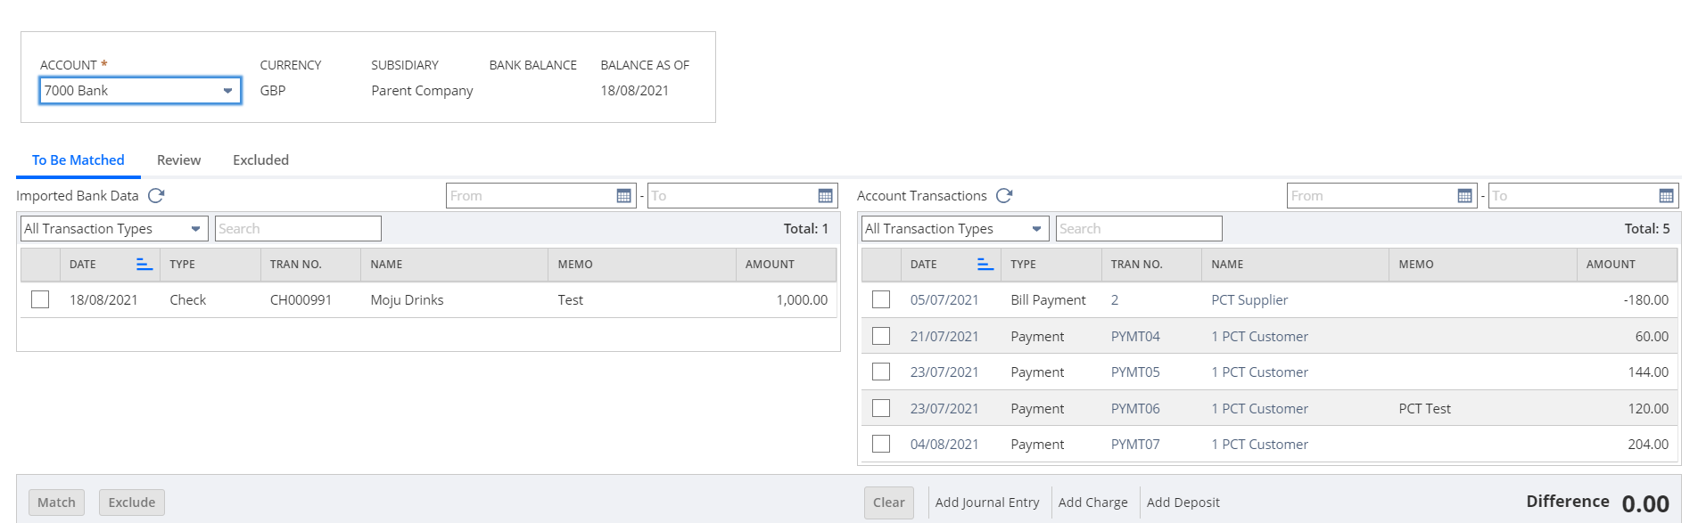
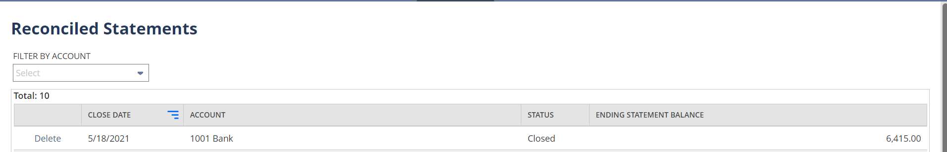
Once you reconcile the statement, you will be re-directed to a page where you can see all the reconciled statements.

